**Project Instructions**

**Date Submitted:** March 2, 2022

**Platform:** NOAA Ship *Oscar Dyson*

**Project Number:** DY-22-06 (OMAO)

**Project Title:** EcoFOCI Spring Mooring Cruise and Hydrographic Survey

**Project Dates:** May 2, 2022 to May 14, 2022

Prepared by: 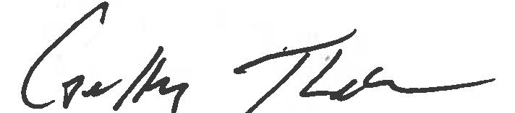 Dated: 06 April, 2022  
 Geoff Lebon

Chief Scientist

NOAA-PMEL

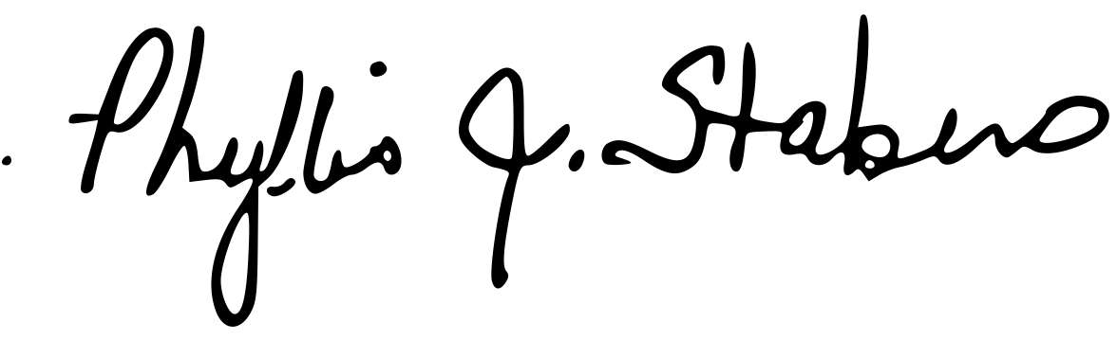

Approved by: Dated: 06 April, 2022  
 Dr. Phyllis Stabeno

Program Lead - EcoFOCI

NOAA/PMEL

Approved by: ________________________ Dated: __________________  
Dr. Michelle McClure   
Director - PMEL  
NOAA/PMEL

Approved by: ________________________ Dated: __________________

Captain Jeffrey Taylor, NOAA

Commanding Officer

Marine Operations Center – Pacific

**I. Overview**

A. Brief Summary and Project Period

EcoFOCI Spring Mooring cruise and hydrographic/biological survey; May 2, 2022 to May 14, 2022

B. Days at Sea (DAS)

Of the 13 DAS scheduled for this project, 0 DAS are funded by an OMAO allocation, 13 DAS are funded by a Line Office Allocation, 0 DAS are Program Funded, and 0 DAS are Other Agency funded. This project is estimated to exhibit a high Operational Tempo. This project will require operations up to 24 hrs./day.

C. Operating Area (include map/figure showing op area)

The operating area will consist of the Bering Sea with St Lawrence Island to the North, South to the Aleutian Chain and Unimak Pass, and longitude 177W degrees to the West and longitude 163W degrees to the east. The charts below in Appendix 1 shows the overall operating area along with charts for the operating area of each type of operation.

D. Summary of Objectives

This project is intended to recover five (5) subsurface moorings, deploy four (4) subsurface moorings and two (2) surface moorings at the Bering Sea sites of M2, M4, M5 and UPP3 which is south of Unimak Pass. In addition, three (3) marine mammal moorings are to be recovered and three (3) additional marine mammal moorings will be deployed. A hydrographic/biological survey consisting of **C**onductivity/**T**emperature/**D**epth (**CTD**) casts, 20/60 cm bongo tows and **C**alifornia **V**ertical **E**gg **T**ows (**C**al**VET**s) in the Unimak Pass area, along the 70-meter isobath in the Bering Sea as far north as the sea ice permits, and in boxes around the 4 mooring sites at M2, M4, M5, and M8. Additionally, we will deploy four (4 ) popup buoys and up to 58 Sonobuoys. If time permits, a 20/60 bongo survey of up to 31 stations will be conducted in the area of the Pribilof Islands as time permits, only 27 of the proposed 31 stations will be occupied at a maximum.

E. Participating Institutions

NOAA – Pacific Marine Environmental Laboratory (PMEL)

7600 Sand Point Way NE

Seattle WA 98115

NOAA – Alaska Fisheries Science Center (AFSC)

7600 Sand Point Way NE

Seattle, WA 98115

Cooperative Institute for Climate, Ocean, and Ecosystem Studies (CICOES)

University of Washington

3737 Brooklyn Ave.

Seattle, WA 98105-6715

University of Alaska Fairbanks

[2150](https://maps.google.com/?q=24+Colovos+Rd.+%0D%0A+Durham,+NH+03824+%0D%0A+603&entry=gmail&source=g) Koyukuk Dr.

[Fairbanks,](https://maps.google.com/?q=24+Colovos+Rd.+%0D%0A+Durham,+NH+03824+%0D%0A+603&entry=gmail&source=g) AK 99775

US Fish and Wildlife Service, Alaska Region

1011 East Tudor Road

Anchorage, AK 99503

F. Personnel/Science Party: name, title, gender, affiliation, and nationality

|  |  |  |  |  |  |  |
| --- | --- | --- | --- | --- | --- | --- |
| **Name (Last, First)** | **Title** | **Date Aboard** | **Date Disembark** | **Gender** | **Affiliation** | **Nationality** |
| Bell, Shaun | Scientist | 1-May-22 | 15-May-22 | M | NOAA/PMEL | US |
| Crance, Jessica | Scientist | 1-May-22 | 15-May-22 | F | NOAA/NMFS | US |
| Crouser, Deana | Scientist | 1-May-22 | 15-May-22 | F | NOAA/NMFS | US |
| Ekmanis, Iris | Scientist | 1-May-22 | 15-May-22 | F | NOAA Corps | US |
| Gann, Jeanette | Scientist | 1-May-22 | 15-May-22 | F | NOAA/NMFS | US |
| Hilman, Paul | Scientist | 1-May-22 | 15-May-22 | M | NMFS | US |
| Kimmel, Dave | Scientist | 1-May-22 | 15-May-22 | M | NOAA/NMFS | US |
| Lebon, Geoff | Scientist | 1-May-22 | 15-May-22 | M | UW/PMEL | US |
| Lemagie, Emily | Scientist | 1-May-22 | 15-May-22 | F | NOAA/PMEL | US |
| Monaci, Natalie | Scientist | 1-May-22 | 15-May-22 | F | UAF | US |
| Reedy, Marty | Scientist | 1-May-22 | 15-May-22 | M | USFWS | US |

G. Administrative

1. Points of Contact:

Geoffrey Lebon (Scientist); JISAO, 7600 Sand Point Way NE, Bldg. 3, Seattle WA, 98115. PH: (206) 526-6884; [Geoffrey.t.lebon@NOAA.GOV](mailto:Geoffrey.t.lebon@NOAA.GOV)

Dr. Phyllis Stabeno (Program Director, Eco-FOCI); 7600 Sand Point Way NE, Bldg. 3, Seattle, WA 98115. PH: (206) 526-6453; [Phyllis.Stabeno@NOAA.GOV](mailto:Phyllis.Stabeno@NOAA.GOV)

Dr. Libby Logerwell, AFSC (Program Director, FOCI); 7600 Sand Point Way NE, Bldg. 4; Seattle, WA 98115. PH: (206) 526-4231; [Libby.logerwell@NOAA.GOV](mailto:Libby.logerwell@NOAA.GOV)

Operations Officer, NOAAS Oscar Dyson; NOAA Corps, 2002 SE Marine Science Drive, Newport, OR 97365. PH: (541) 867-8911 (Ship’s VOIP); [OPS.Oscar.Dyson@NOAA.GOV](mailto:OPS.Oscar.Dyson@NOAA.GOV)

2. Diplomatic Clearances

None required.

3. Licenses and Permits

This project will be conducted under Scientific Research Permit (U.S.) (SRP) #2022-B1; effective dates 04 February 2022 to 30 September, 2022. Issued to Robert Foy, Science and Research Director-AFSC.

**II. Operations**

The Chief Scientist is responsible for ensuring the scientific staff are trained in planned operations and are knowledgeable of project objectives and priorities. The Commanding Officer is responsible for ensuring all operations conform to the ship’s accepted practices and procedures.

A. Project Itinerary:

Scientist report to ship Friday April 29, 2022. Gear loading begins.

Scientist return to hotel, Evening of April 30, 2022

Pre-cruise covid testing, May 01, 2022

Scientist board ship Monday morning, May 02, 2022

Departure: Dutch Harbor, Monday, May 02, 2022

Arrival: Dutch Harbor, Saturday, May 14, 2022

Offload gear upon arrival, Scientist depart ship upon completion of offload.

B. Staging and De-staging:

Two 40-foot containers will be shipped from Seattle and will be staged at OSI in Dutch Harbor. Unloading of the containers and the transfer of equipment to the ship shall occur as appropriate prior to departure. Members of the science party will arrive at least four days prior to departure to assist in the loading of equipment onto the ship, preparation of the moorings and setting up the sampling gear on deck and in the labs. The science party will arrange their own vehicles for transporting personnel and equipment. At the end of the project, all equipment will be removed from the ship and offloaded into a container for shipment back to Seattle. To assist in the unloading of the containers and setting up the moorings, a crane operator will be needed during normal working hours on Friday, April 29th and Saturday, April 30th. Additionally, a crane operator will be needed on May 14th and May 15th to off-load equipment to be packed into the container for shipment to Seattle.

C. Operations to be Conducted:

* 1. **Unimak Box CTDs:** CTDs will be taken at each of 18 stations in the “box” in and around Unimak Pass. At each station within the pass and at every other station along the sides and across the northern line, a 20/60 cm bongo net will be towed for the collection of zooplankton.
  2. **FOCI Bering Sea Mooring Sites M2, M4, and M5** **:** Depending upon arrival time, the operations at site 2 will commence with mooring operations or the CTD box. Mooring operations will consist of the recovery of existing moorings at each site, which includes one (1) subsurface mooring at M2 and two (2) subsurface moorings at sites M4 and M5. These will be followed by the deployment of one (1) subsurface mooring and two (2) surface moorings at site M2 and two (2) subsurface moorings at site M4. Only a puff mooring will be deployed at M5 if sea ice permits. The CTD box will consist of a CTD and 20/60 cm bongo at each of four (4) corner stations of the box and a CTD, bongo and three (3) CalVET tows at the location of the mooring in the center of the box. Depending upon water sampling requirements, the CTD at the mooring location may have to be done twice to get adequate water samples. The ship will also be tasked with returning to the mooring site up to 24 hours after mooring deployment for additional calibration casts at Site 2. The CTD at the mooring location will serve as a calibration CTD for the moorings. This scenario will be repeated at site M4 with just the CTD boxes being completed at sites M5 and M8. Sites M5 and M8 will only be occupied if the sea is free of ice.
  3. **FOCI Gulf of Alaska Mooring site UPP1:** A mooring will be deployed at site UPP3 (Unimak Pass). A CTD cast will be performed at the site.
  4. **70-meter Isobath Survey Line:** A CTD cast with sampling for salinity, chlorophyll, nutrients and oxygen will be conducted at each station along the 70-meter isobath. Stations will commence at Mooring Site 2 and continue as far north to Site 8 as permitted by sea ice. CTDs will be conducted to within 5 meters of the bottom unless it is deemed prudent to only go to 10 meters, such as when the ship’s motion is such that the CTD may hit the bottom. Winch speeds should be 30 meters/minute on the down and up cast. A 20/60 cm bongo tow will be conducted at every other station along the 70m isobath survey line.
  5. **Larval Survey Stations:** A 20/60 cm bongo tow will be performed at each Of 27 survey stations as time permits. These stations are located near the middle of the 72 m isobath in the area of the Pribilof Islands. Some of these stations will also have corresponding CTDs depending on how much is time allotted to the survey grid.
  6. **Marine Mammal Moorings:** Marine Mammals moorings will be turned around at mammal sites Unimak Pass, BS10, and Umnak. CTD’s will be conducted at each of these sites to validate the sound velocity.
  7. **Sonabuoys:** Up to58Sonabuoys will be deployed over the side while transiting between stations and every 3 hours while steaming over long periods of time for documentation of marine mammals. Tracking antennas will need to be mounted on the ships flying bridge before departure.
  8. **Popup Moorings: Up to** five (5) popup moorings will be deployed during the cruise throughout the Bering Sea. The popup moorings can be deployed easily from the side of the vessel by being lowered to the water surface with a hand line and released or by a quick release using the outhaul on the A-frame.
  9. **Seabird Observations:** Observations of seabirds will be conducted whenever underway during daylight hours if visibility and the ship’s transit speed permit.
  10. **Underway System:** The underway system will be adapted to such that a TDGP (Total dissolved gas pressure) instrument can be added to the system. This will be done in conjunction with the CO2 program. An IFCB (Imaging Flow Cytobot) system will also be plumbed into the underway water for the cruise.

D. Dive Plan

All dives are to be conducted in accordance with the requirements and regulations of the NOAA Diving Program (<http://www.ndc.noaa.gov/dr.html>) and require the approval of the ship’s Commanding Officer.

Dives are not planned for this project.

E. Applicable Restrictions

Conditions which preclude normal operations: poor weather, equipment failure, unforeseen conditions, and ice coverage would all preclude normal operations. Poor weather would have to be waited out or the project track would have to be modified to provide the best prospects for completing the project. A-frame and winch failures would have to be addressed immediately for the project to continue. Ice coverage would negate the ability to conduct mooring and/or CTD/Bongo operations, these would have to be postponed for later in the project, or conducted during subsequent projects or from another vessel. Additionally, surface floats will not be deployed if there is a possibility of ice in their location.

**III. Equipment**

A. Equipment and Capabilities provided by the ship (itemized)

Hydrographic winch with slip rings and 2-conductor cable terminated for the CTD,

Sea-Bird Electronics’ SBE 911 plus CTD system with stand and dual Temperature and Conductivity sensors, each CTD system should include underwater CTD, weights, and altimeter, there should be a deck unit for the system,

10-liter Niskin sampling bottles for use with the CTD rosette (11 bottles plus 4 spares).

A second hydrographic winch with slip rings and 2-conductor cable terminated for the SBE 19plus for net tow operations – bongos and CalVETs.

12 kHz hull mounted EdgeTech Acoustic release transducer and deck unit,

Scientific Computer System (SCS),

For meteorological observations: 2 anemometers (one R. M. Young system interfaced with the SCS), calibrated air thermometer (wet- and dry-bulb) and a calibrated barometer and/or barograph,

Freezer space for storage of biological and chemical samples (-20° and -80°C), turned on and operating,

SIMRAD ES-60 and EK-80 echo sounders,

A minimum of two (2) computer workstations in the acoustic lab with Internet, printer and email access,

Removable stern platform in place,

Laboratory space with storage space,

Underway flow-through seawater system with TSG,

Seawater hoses and nozzles to wash nets,

Adequate deck lighting for nighttime operations,

Navigational equipment including GPS and radar,

Safety harnesses and floatation equipment for working on the side sample platform and fantail,

Ship’s cranes used for loading and/or recovering and deploying moorings,

Work boat available for mooring repairs or recovery if needed.

B. Equipment and Capabilities provided by the scientists (itemized)

Sea-Bird Electronics SBE 19 Plus SEACAT system,

Fluorometer, light meter (PAR), and dual oxygen systems to be mounted on the CTD (backup),

Four (4) Subsurface moorings, floats, instruments, chain,

Two (2) Surface moorings, floats, instruments, chain,

Three (3) Marine Mammal subsurface moorings,

Five (5) Popup buoys,

Equipment to deploy and recover moorings,

Dragging gear as needed to drag for moorings in event of failure to release,

20/60 cm bongo net systems,

Manual wire angle indicator,

CalVET net sampling system,

Underway system instrumentation.

Scientific sampling supplies and storage/preservation supplies,

One case plus 10 singles totaling 58 Sonobuoys.

IFCB underway system.

Estimated weights of the gear is shown in the table in appendix #. A final weight will be tallied upon loading the containers at PMEL. All parcels loaded into the container will be tagged with their weight. This list will be passed to the Captain upon loading and the total weight to be loaded onto the ship will not exceed 38,000 pounds.

**IV. Hazardous Materials**

A. Policy and Compliance

The Chief Scientist is responsible for complying with FEC 07 Hazardous Materials and Hazardous Waste Management Requirements for Visiting Scientific Parties (or the OMAO procedure that supersedes it). By Federal regulations and NOAA Marine and Aviation Operations policy, the ship may not sail without a complete inventory of all hazardous materials by name and quantity, MSDS, appropriate spill cleanup materials (neutralizing agents, buffers, or absorbents) in amounts adequate to address spills of a size equal to the amount of chemical brought aboard, and chemical safety and spill response procedures. Documentation regarding those requirements will be provided by the Chief of Operations, Marine Operations Center, upon request.

Per OMAO procedure, the scientific party will include with their project instructions and provide to the CO of the respective ship 30 days before departure:

* + - List of chemicals by name with anticipated quantity
    - List of spill response materials, including neutralizing agents, buffers, and absorbents
    - Chemical safety and spill response procedures, such as excerpts of the program’s Chemical Hygiene Plan or SOPs relevant for shipboard laboratories
    - For bulk quantities of chemicals in excess of 50 gallons total or in containers larger than 10 gallons each, notify ship’s Operations Officer regarding quantity, packaging and chemical to verify safe stowage is available as soon as chemical quantities are known.

Upon embarkation and prior to loading hazardous materials aboard the vessel, the scientific party will provide to the CO or their designee:

* An inventory list showing actual amount of hazardous material brought aboard
* An MSDS for each material
* Confirmation that neutralizing agents and spill equipment were brought aboard sufficient to contain and cleanup all of the hazardous material brought aboard by the program
* Confirmation that chemical safety and spill response procedures were brought aboard

Upon departure from the ship, scientific parties will provide the CO or their designee an inventory showing that all chemicals were removed from the vessel. The CO’s designee will maintain a log to track scientific party hazardous materials. MSDS will be made available to the ship’s complement, in compliance with Hazard Communication Laws.

Scientific parties are expected to manage and respond to spills of scientific hazardous materials. Overboard discharge of hazardous materials is not permitted aboard NOAA ships.

B. Inventory

**Oxygen Analysis Chemicals, property of PMEL:**

|  |  |  |  |  |  |
| --- | --- | --- | --- | --- | --- |
| **Common Name** | **Concentration** | **Qty** | **Trained**  **Individual** | **Spill Response** | **Notes** |
| Manganese Chloride | 3 M | 2 x 500 ml | Geoffrey  Lebon | Gloves, Paper Towels, Kitty litter, Plastic bags | Not a regulated chemical /solution. |
| Potassium Iodate | 0.00234 M | 2 x 500 ml | Geoffrey  Lebon | Spill Control PI, Gloves, Kitty litter, Plastic bags | Store in Acid Locker in Chem. Lab. |
| Sodium Iodide/NaOH Solution | 4 M NaI, 8 M NaOH | 2 x 500 ml | Geoffrey  Lebon | Spill Control B | Store in Acid Locker in Chem. Lab. |
| Sodium Thiosulfate | 0.16 M | 2 x 500 ml | Geoffrey  Lebon | Spill Control ST | Store in Acid Locker in Chem. Lab. |
| Sulfuric Acid | 5 M | 2 x 500 ml | Geoffrey  Lebon | Spill Control A | Store in Acid Locker in Chem. Lab. |

**Fish/Zooplankton sampling chemicals, property of NMFS:**

|  |  |  |  |  |  |
| --- | --- | --- | --- | --- | --- |
| **Common Name /Responsibility** | **Concentration** | **Qty** | **Trained**  **Individual** | **Spill Response** | **Notes** |
| Ethanol/FOCI | 100% | 5 – 1-gallon plastic jugs | David Kimmel | Spill Response E, Gloves, 3M absorbent Pads, Plastic bags | Store in Chem Lab, yellow flammable locker |
| Paraformaldehyde | 10% | 3- 7ml vials | Jeanette Gann | Spill Control F, Gloves, eye protection, Fan-Pads, Foramalex, PolyForm-F, plastic bags | Store in -80 Freezer |
| Formaldehyde /FOCI | 37% | 4 – 2.5-gallon barrels | David Kimmel | Spill Control F, Gloves, eye protection, Fan-Pads, Foramalex, PolyForm-F, plastic bags | Store in Fish Lab Flammable cabinets. Will need to place 4 in each cabinet. |
| Sodium Azide | 4% | 500 ml | Jeanette Gann | Spill Control SA. Gloves, eye protection, absorbent, plastic bags | Store in Haz Chem locker |
| Sodium Borate Solution/FOCI | 5-6% | 1 – 5-gallon carboy | David Kimmel | Gloves, Paper towels, plastic bags | Not a regulated chemical. Working container will be secured on Fish Lab bench |
| Sodium Borate Powder/FOCI | 100% | 1 – 500 g | David Kimmel | Gloves, wet paper towels, plastic bags | Not a regulated chemical, stored in Spill kit |

**UAF Chemicals:**

|  |  |  |  |  |  |
| --- | --- | --- | --- | --- | --- |
| **Common Name** | **Concentration** | **Qty** | **Trained Individual** | **Spill Response** | **Notes** |
| Compressed Air | Calibration gas used in the CO2 system on Peggy Buoy | 2 tanks (roughly the size of dive tanks) | Natalie Monaci | NA |  |
| Mercuric Chloride | Saturated Solution | 0.10 liter | Natalie Monaci | Spill Control M |  |

Lithium Batteries, Property of PMEL:

C. Chemical safety and spill response procedures

**A: ACID**

* Wear appropriate protective equipment and clothing during clean-up. Keep upwind. Keep out of low areas.
* Ventilate closed spaces before entering them.
* Stop the flow of material, if this is without risk. Dike the spilled material, where this is possible.
* **Large Spills**: Dike far ahead of spill for later disposal. Use a non-combustible material like vermiculite, sand or earth to soak up the product and place into a container for later disposal.
* **Small Spills**: Wipe up with absorbent material (e.g. cloth, fleece). Clean surface thoroughly to remove residual contamination.
* Never return spills in original containers for re-use.
* Neutralize spill area and washings with soda ash or lime. Collect in a non-combustible container for prompt disposal.

**B: BASE**

* Wear appropriate protective equipment and clothing during clean-up. Keep upwind. Keep out of low areas.
* Ventilate closed spaces before entering them.
* Stop the flow of material, if this is without risk. Dike the spilled material where this is possible.
* **Large Spills**: Dike far ahead of spill for later disposal. Use a non-combustible material like vermiculite, sand or earth to soak up the product and place into a container for later disposal.
* **Small Spills**: Wipe up with absorbent material (e.g. cloth, fleece). Clean surface thoroughly to remove residual contamination.
* Never return spills in original containers for re-use.
* Neutralize spill area and washings with dilute acid such as 10% HCl if possible. Collect in a non-combustible container for prompt disposal.

**E: Ethanol**

* Ventilate area of leak or spill. Remove all sources of ignition.
* Wear appropriate personal protective equipment.
* Isolate hazard area. Keep unnecessary and unprotected personnel from entering. Contain and recover liquid when possible.
* Use non-sparking tools and equipment. Collect liquid in an appropriate container or absorb with an inert material (e. g., vermiculite, dry sand, earth), and place in a chemical waste container.
* Do not use combustible materials, such as saw dust.

**F: Formalin/Formaldehyde**

* Ventilate area of leak or spill. Remove all sources of ignition.
* Wear appropriate personal protective equipment.
* Isolate hazard area. Keep unnecessary and unprotected personnel from entering. Contain and recover liquid when possible.
* Use non-sparking tools and equipment. Collect liquid in an appropriate container or absorb with an inert material (e. g., vermiculite, dry sand, earth), and place in a chemical waste container.
* Do not use combustible materials, such as saw dust.

**M: Mercury**

* Spills: Pick up and place in a suitable container for reclamation or disposal in a method that does not generate dust. Sprinkle area with sulfur or calcium polysulfide to suppress mercury. Use Mercury Spill Kit if need be.

**PI: Potassium Iodate**

* Wear appropriate personal protective equipment.
* Avoid contact with combustibles (wood, paper, clothing, etc.)
* Absorb with kitty litter or vermiculite.
* Do not use combustible materials, such as saw dust.
* Keep substance damp with water spray.
* Vacuum or sweep up material and place into suitable disposable container (plastic bags).

**SA: Sodium Azide (5%)**

* Wear protective gloves and eye protection.
* Normal room ventilation is adequate.
* Chemical resistant gloves.
* Safety glasses or goggles.
* Do not flush to sewer. Absorb with chemical absorbent pads and place in non-metal container. Containerize for disposal with a hazardous waste disposal facility. Dispose of in accordance with local regulations

**ST: Sodium Thiosulfate**

* Ventilate area of leak or spill.
* Wear appropriate personal protective equipment.
* Use chemical safety goggles. Maintain eye wash fountain and quick-drench facilities in work area.
* Avoid contact with combustibles (wood, paper, clothing, etc.)
* Absorb with kitty litter or vermiculite.
* Do not use combustible materials, such as saw dust.
* Recover liquid or particulate in 5-gallon bucket.

**PMEL Acid-Base Spill Kit Contents:**

|  |  |  |  |  |
| --- | --- | --- | --- | --- |
| **Common Name** | **Amount** | **Use** | **Total Spill Volume Controllable** | **Notes** |
| Spilfyter Acid Neutralizer | 1 Box | Clean up acid spill – H2SO4 | 1.5 liters of 5M Sulfuric Acid |  |
| Spilfyter Base Neutralizer | 1 Box | Clean up base spill – NaOH | 2.0 liters of NaOH |  |
| Vinyl Gloves | 1 box each M, L and XL | Protect hands during all cleanups | NA |  |
| Foxtail/Dust pan | 1 each | Pick up absorbed neutralizer | NA |  |
| Rubber Apron | 1 each | Protect personnel during cleanup | NA |  |
| Paper Towels | 1 roll | Absorb small amounts of liquids | NA |  |
| Goggles | 2 pair | Protect eyes during cleanups | NA |  |
| Chemical Absorbent (kitty litter) | 1 liter | Absorb liquids | 0.5 liters |  |
| Plastic Bags | 2 each | Contain used absorbents/waste | NA |  |

**FOCI Spill Kit Contents:**

|  |  |  |  |  |
| --- | --- | --- | --- | --- |
| **Common Name** | **Amount** | **Use** | **Total Spill Volume Controllable** | **Notes** |
| Formalex | 1 – 5 gallons 2 – 1 gallon | Formaldehyde cleanup, (all concentrations) | 1:1 control | Formalex will be used in conjunction with Fan-Pads to reduce spill volumes. |
| Fan-Pads | 2 rolls (50 sheets per roll) | Formaldehyde cleanup, (all concentrations) | 50 sheets = 50 – 150 ml spills | Formalex will be used in conjunction with Fan-Pads to reduce spill volumes. |
| PolyForm-F | 1 – 5-gallon bucket | Formaldehyde cleanup, (all concentrations) | 1:1 control | Pour onto large spill immediately to deactivate formaldehyde. |
| 3 M Pads | 10 pads | Ethanol cleanup | 10 pads = 10 – 250 ml spills | Pads may be reused if dried out under fume hood. |
| Nitrile Gloves | 8 pairs each: S, M, L, XL | For all cleanup procedures | NA | Gloves will be restocked by each survey group. |
| Eye protection | 4 pairs goggles,1 face shield | Formaldehyde cleanup | NA | Eye protection will be cleaned before reuse |
| Tyvek Lab Coats | 2 coats | Formaldehyde cleanup | NA | Coats will be cleaned with Fan-Pads and Formalex before reuse. |
| Plastic Bags | 2 | Formaldehyde cleanup/Fan-Pads | NA | Bags may be packed full and sealed. |

D. Radioactive Materials

No Radioactive Isotopes are planned for this project.

E. Lithium batteries

1. Lithium Batteries, property of PMEL:

|  |  |  |  |
| --- | --- | --- | --- |
| **Size** | **Qty** | **Spill Response** | **Notes** |
| 9V | 46 | NA | In SeaBird and WET Labs instruments |
| AA | 76 | NA | In SeaBird instruments and MicroCATs Saft LS14500 |
| D | 0 | NA | In RCM9 |
| BCX85D | 32 | NA | In Prawler moored instrument package |
| DL123 6V | 58 | NA | In Sonabuoys |

2. Lithium Battery Risk Management Plan:

a. All lithium batteries are packaged under UN3091, contained within equipment.

b. No equipment will be opened up while at sea to change out batteries.

c. All equipment with batteries shipped to the Dyson will be deployed on moorings.

d. All moorings recovered with instruments containing Li batteries will be shipped back to PMEL upon completion of the cruise for proper care and disposal.

e. Instruments containing Li batteries will be stored on the back deck in a wire cage or in the sorting lab in boxes labeled as containing Li batteries. The operations officer will be alerted to these locations.

f. A class D fire extinguisher will be provided by the scientific party. This will be turned over to the safety officer upon loading of the ship.

**V. Additional Projects**

A. Supplementary (“Piggyback”) Projects

No Supplementary Projects are planned.

B. NOAA Fleet Ancillary Projects

No NOAA Fleet Ancillary Projects are planned.

**VI. Disposition of Data and Reports**

Disposition of data gathered aboard NOAA ships will conform to NAO 216-101 *Ocean Data Acquisitions* and NAO 212-15 *Management of Environmental Data and Information.* To guide the implementation of these NAOs, NOAA’s Environmental Data Management Committee (EDMC) provides the *NOAA Data Documentation Procedural Directive* (data documentation) and *NOAA Data Management Planning Procedural Directive* (preparation of Data Management Plans). OMAO is developing procedures and allocating resources to manage OMAO data and Programs are encouraged to do the same for their Project data.

1. Data Classifications: *Under Development*
   1. OMAO Data
   2. Program Data
2. Responsibilities: *Under Development*

**VII. Meetings, Vessel Familiarization, and Project Evaluations**

1. Pre-Project Meeting: The Chief Scientist and Commanding Officer will conduct a meeting of pertinent members of the scientific party and ship’s crew to discuss required equipment, planned operations, concerns, and establish mitigation strategies for all concerns. This meeting shall be conducted before the beginning of the project with sufficient time to allow for preparation of the ship and project personnel. The ship’s Operations Officer usually is delegated to assist the Chief Scientist in arranging this meeting.
2. Vessel Familiarization Meeting: The Commanding Officer is responsible for ensuring scientific personnel are familiarized with applicable sections of the standing orders and vessel protocols, e.g., meals, watches, etiquette, drills, etc. A vessel familiarization meeting shall be conducted in the first 24 hours of the project’s start and is normally presented by the ship’s Operations Officer.
3. Post-Project Meeting: The Commanding Officer is responsible for conducted a meeting no earlier than 24 hrs. before or 7 days after the completion of a project to discuss the overall success and shortcomings of the project. Concerns regarding safety, efficiency, and suggestions for future improvements shall be discussed and mitigations for future projects will be documented for future use. This meeting shall be attended by the ship’s officers, applicable crew, the Chief Scientist, and members of the scientific party and is normally arranged by the Operations Officer and Chief Scientist.
4. Project Evaluation Report: Within seven days of the completion of the project, a Customer Satisfaction Survey is to be completed by the Chief Scientist or Principal Investigator, as appropriate. The form is available at [https://sites.google.com/a/noaa.gov/omao-intranet-dev/operations/marine/customer-satisfaction-survey](https://docs.google.com/a/noaa.gov/forms/d/1a5hCCkgIwaSII4DmrHPudAehQ9HqhRqY3J_FXqbJp9g/viewform) and provides a “Submit” button at the end of the form. It is also located at <https://docs.google.com/a/noaa.gov/forms/d/1a5hCCkgIwaSII4DmrHPudAehQ9HqhRqY3J_FXqbJp9g/viewform>. Submitted form data is deposited into a spreadsheet used by OMAO management to analyze the information. Though the complete form is not shared with the ships, specific concerns and praises are followed up on while not divulging the identity of the evaluator.

**VIII. Miscellaneous**

A. Meals and Berthing

The ship will provide meals for the scientists listed above. Meals will be served 3 times daily beginning one hour before scheduled departure, extending throughout the project, and ending two hours after the termination of the project. Since the watch schedule is split between day and night, the night watch may often miss daytime meals and will require adequate food and beverages (for example a variety of sandwich items, cheeses, fruit, milk, juices) during what are not typically meal hours. Special dietary requirements for scientific participants will be made available to the ship’s command at least seven days prior to the project.

Berthing requirements, including number and gender of the scientific party, will be provided to the ship by the Chief Scientist. The Chief Scientist and the Operations Officer will work together on a detailed berthing plan to accommodate the gender mix of the scientific party taking into consideration the current makeup of the ship’s complement. The Chief Scientist is responsible for ensuring the scientific berthing spaces are left in the condition in which they were received; for stripping bedding and linen return; and for the return of any room keys which were issued. Unless prior arrangements are made, the science party may move aboard the night before scheduled departure and must move off the ship the day after scheduled arrival (at the end of project). The Chief Scientist/Principal Investigator is also responsible for the cleanliness of the laboratory spaces and the storage areas utilized by the scientific party, both during the project and at its conclusion prior to departing the ship.

All NOAA scientists will have proper travel orders when assigned to any NOAA ship. The Chief Scientist will ensure that all non-NOAA or non-Federal scientists aboard also have proper orders. It is the responsibility of the Chief Scientist or Principal Investigator to ensure that the entire scientific party has a mechanism in place to provide lodging and food and to be reimbursed for these costs in the event that the ship becomes uninhabitable and/or the galley is closed during any part of the scheduled project.

All persons boarding NOAA vessels give implied consent to comply with all safety and security policies and regulations which are administered by the Commanding Officer. All spaces and equipment on the vessel are subject to inspection or search at any time. All personnel must comply with OMAO's Drug and Alcohol Policy dated May 17, 2000, which forbids the possession and/or use of illegal drugs and alcohol aboard NOAA Vessels.

B. Medical Forms and Emergency Contacts

The NOAA Health Services Questionnaire (NHSQ, NF 57-10-01 (3-14)) must be completed in advance by each participating scientist. The NHSQ can be obtained from the Chief Scientist or the NOAA website <http://www.corporateservices.noaa.gov/noaaforms/eforms/nf57-10-01.pdf>.

NHSQs must be submitted every 2 years for individuals under the age of 50 and every 1 year for ages 50 and above. NHSQs must be accompanied by [NOAA Form (NF) 57-10-02](http://www.corporateservices.noaa.gov/~noaaforms/eforms/nf57-10-02.pdf) - Tuberculosis Screening Document in compliance with [OMAO Policy 1008](http://www.omao.noaa.gov/find/media/documents/omao-1008-tuberculosis-protection-program) (Tuberculosis Protection Program, which requires a yearly PPD or TB exam). A copy of current covid vaccination status shall also be provided to NOAA Health.

The completed forms should be sent to Marine Health Services at the applicable Marine Operations Center. The NHSQ and Tuberculosis Screening Document should reach the Health Services Office no later than 4 weeks prior to the start of the project to allow time for the participant to obtain and submit additional information should health services require it, before clearance to sail can be granted. Please contact MOC Health Services with any questions regarding eligibility or completion of either form. Ensure to fully complete each form and indicate the ship or ships the participant will be sailing on. The participant will receive an email notice when medically cleared to sail if a legible email address is provided on the NHSQ.

The participant can mail, fax, or email the forms to the contact information below. Participants should take precautions to protect their Personally Identifiable Information (PII) and medical information and ensure all correspondence adheres to DOC guidance (<http://ocio.os.doc.gov/ITPolicyandPrograms/IT_Privacy/PROD01_008240>).

The only secure submission process approved by NOAA is [kiteworks](https://sfc.doc.gov/) by Accellion Secure File Transfer, which requires the sender to set up an account using a valid NOAA email address and password. User accounts may expire after 30 days of inactivity. Simply re-register to send and receive files.

Persons without a NOAA email account must fax or mail their forms.

Contact information:

|  |  |
| --- | --- |
| Marine Health Services  Marine Operations Center – Pacific  2002 SE Marine Science Dr.  Newport, OR 97365  Telephone 541-867-8822  Fax 541-867-8856  Email [MOP.Health-Services@noaa.gov](mailto:MOP.Health-Services@noaa.gov) |  |

Prior to departure, the Chief Scientist must provide an electronic listing of emergency contacts to the Executive Officer for all members of the scientific party, with the following information: contact name, address, relationship to member, and telephone number.

C. Shipboard Safety

All personnel who embark are to fully support and comply with NOAA Administrative Order 202-1106: NOAA Sexual Assault and Sexual Harassment Prevention and Response Policy.  The at-sea working/living environment is particularly sensitive and it is incumbent upon all personnel to uphold a positive and professional workplace dynamic in order to successfully accomplish cruise objectives.

Surge protectors, power strips and Uninterrupted Power Sources (UPS) must be approved for marine/shipboard use, removed from service if hot to the touch, regularly inspected for damage or wear, limited to one surge protector per duplex receptacle (i.e., “outlet”), and never daisy chained. The equipment must meet MIL Performance Specification MIL-PZRF-32167A, which incorporates ASTM F1507 (Standard Specifications for Surge Suppressors for Shipboard Use) and UL 1449 (Safety

Standards for Surge Protective Devices).

Hard hats are required when working with suspended loads.  Work vests are required when working near open railings and during small boat launch and recovery operations.  Hard hats and work vests will be provided by the ship when required.

Wearing open-toed footwear or shoes that do not completely enclose the foot (such as sandals or clogs) outside of private berthing areas is not permitted.  At the discretion of the ship CO, safety shoes (i.e. steel or composite toe protection) may be required to participate in any work dealing with suspended loads, including CTD deployment and recovery.  The ship does not provide safety-toed shoes/boots.  The ship’s Operations Officer should be consulted by the Chief Scientist to ensure members of the scientific party report aboard with the proper attire.

D. Communications

A progress report on operations prepared by the Chief Scientist may be relayed to the program office. Sometimes it is necessary for the Chief Scientist to communicate with another vessel, aircraft, or shore facility. Through various means of communications, the ship can usually accommodate the Chief Scientist. Special radio voice communications requirements should be listed in the project instructions. The ship’s primary means of communication with the Marine Operations Center is via email and the Very Small Aperture Terminal (VSAT) link. Standard VSAT bandwidth has increased, on average per ship, to 768 kbs and is shared by all vessel’s staff and the science team at no charge to sailing personnel. Increased bandwidth in 7-day increments is available on the VSAT systems at increased cost to the scientific party. If increased bandwidth is being considered, program accounting is required and it must be arranged through the ship’s Commanding Officer at least 30 days in advance.

1. IT Security

The applicable sections below are required prior to boarding the ship.

1. **Guest Scientist Access to Ship Science Systems**
2. IT Security Awareness Training:
   1. It is recommended that guests complete the course 3 days before embarking, but must be completed prior to use of or accessing any NOAA ship science computer or network resources guest scientists must complete NOAA’s IT Security Awareness Course.
3. Guest scientists must review and sign the Rules of Behavior (ROB)
4. For Foreign Nationals see section 8.F.

**b. Connecting Guest Scientist Computer Systems to NOAA Ships Science Network**

1. Any computer that will be hooked into the ship's network must comply with the *OMAO Fleet IT Security Policy* 1.1 (November 4, 2005) prior to establishing a direct connection to the NOAA WAN. Requirements include, but are not limited to:
2. Installation of the latest virus definition (.DAT) file on all systems and performance of a virus scan on each system.
3. Installation of the latest critical operating system security patches.
4. No external public Internet Service Provider (ISP) connections.
5. No Kaspersky products are allowed
6. Computer Operating Systems that the support vendor has identified as reaching “End of Life” for support will not be allowed on the shipboard network. Examples include Microsoft Windows XP and Vista as well as Windows Server 2003, Windows 7, Server 2003, and Server 2008.

**c. Guest Personal Devices, use of Public Wi-Fi**

At any time, NOAA OMAO may monitor and/or audit user activity and/or network traffic. In addition, NOAA OMAO may access your system and disclose information obtained through audits to third parties, including law enforcement authorities.

1. Guests must review and sign the Rules of Behavior
2. No Kaspersky products are allowed

**References:** *OMAO Fleet IT Security Policy* 1.1 (November 4, 2005), NOAA220 Rules of Behavior for Public Wi-Fi, NOAA220 Rules of Behavior for LAN.

F. Foreign National Guests Access to OMAO Facilities and Platforms

Foreign National access to the NOAA ship or Federal Facilities is not required for this project.

**IX. COVID-19 Contingency Plan for Scientific Party**

In the event of a non-negative test result for any member of the scientific party, or the identification of recent close contact with a positive COVID-19 case through contact tracing:

* The member will not be cleared to board the ship, and lodging will be provided the Grand Aleutian Hotel at **(program or partner)**expense for up to **6**days.
* The Chief Scientist will be notified of any mission personnel who are not cleared to sail.
* The Chief Scientist will determine, in consultation with the ship's command and appropriate parties, whether the mission will continue without the uncleared personnel.
* Subsequent testing will be sought using**(program's IDIQ contract, local commercial testing facility, or whatever other option programs may want to use)**.

In the event a member of the scientific party develops symptoms of possible COVID-19 while underway, [OMAO protocols](https://drive.google.com/drive/folders/1R-_yLaBfGrOS2teXBxGeRUqUIrD94vU0?usp=sharing) will be followed.

* Once ashore, all logistics and support for the affected scientist(s) will be coordinated through shoreside Point of Contact:

CDR Sarah Duncan

NOAA/PMEL

206-526-4485

pmel.dir.ops@noaa.gov

Seattle, WA. Pacific Daylight Savings time (-7)

* Duties of the shoreside support person/team include coordination of:
  + further testing
  + daily well-being check-in & symptom screening
  + travel
  + lodging
  + medical support
  + onsite support as needed
  + notify
    - * Nicole Turpin
      * Medical Clearance Coordinator, MOC-P, NOAA
      * cell: 619-200-4742
      * [nicole.l.turpin@noaa.gov](mailto:nicole.l.turpin@noaa.gov) and [MO.MCC@noaa.gov](mailto:MO.MCC@noaa.gov)

**X. Appendices**

**Appendix I: Station List and Maps**

1. Station/Waypoint List (coordinates in Latitude, Longitude: degree-minutes)

|  |  |  |  |
| --- | --- | --- | --- |
| **Sta. Name** | **Activity** | **Lat.dd** | **Lon.dd** |
| **Depart Dutch Harbor** | **DEPART** |  |  |
| **21UPP-1A** | **Recover Subsurface Mooring** | **54 20.00** | **164 01.830** |
| **22UPP-1A** | **Deploy subsurface Mooring** | **54 20.97** | **164 02.92** |
| **22UPP-1A** | **CTD Cal Cast** | **54 20.97** | **164 02.92** |
| **AL21_AU_UN01a** | **Recover Subsurface Mooring** | **54 26.** | **165 16.2** |
|  | **CTD SV Cast** | **54 26.16** | **165 16.2** |
| **AL22_AU_UN01a** | **Deploy subsurface Mooring** | **54 26.16** | **165 16.2** |
| **UBS1** | **CTD/BON** | **54 26.46** | **164 59.1** |
| **UBS2** | **CTD/BON** | **54 25.14** | **165 8.46** |
| **UBS3** | **CTD** | **54 22.5** | **165 16.62** |
| **UBS4** | **CTD/BON** | **54 20.5** | **165 25.74** |
| **UBW1** | **CTD/BON** | **54 21.48** | **165 55.74** |
| **UBW2** | **CTD/BON** | **54 28.32** | **166 2.34** |
| **UBW3** | **CTD** | **54 34.98** | **166 7.74** |
| **UBW4** | **CTD/BON** | **54 41.28** | **166 14.22** |
| **UBN1** | **CTD/BON** | **54 45.06** | **166 3.06** |
| **UBN2** | **CTD/BON** | **54 48.78** | **165 51.48** |
| **UBN3** | **CTD** | **54 52.08** | **165 40.26** |
| **UBN4** | **CTD/BON** | **54 55.8** | **165 28.8** |
| **UBN5** | **CTD** | **54 59.22** | **165 17.22** |
| **UBN6** | **CTD/BON** | **55 2.94** | **165 6.42** |
| **UBE1** | **CTD/BON** | **54 56.22** | **164 59.76** |
| **UBE2** | **CTD** | **54 49.62** | **164 53.64** |
| **UBE3** | **CTD/BON** | **54 42.96** | **164 47.04** |
| **20BS-2** | **CTD Cal Cast** | **56 52.2** | **164 3.0** |
| **21BSP-2A** | **Recover Subsurface Mooring** | **56 52.37** | **164 03.21** |
| **22BSM-2A** | **Deploy Surface Mooring** | **56 52.0** | **164 03.0** |
| **22BSPR-2A** | **Deploy Surface Mooring** | **56 52.0** | **164 03.0** |
| **22BSP-2A** | **Deploy Subsurface Mooring** | **56 52.0** | **164 03.0** |
| **70M2/M2** | **3 CalVETs** | **56 52.2** | **164 3.3** |
| **70M2/M2** | **CTD/BON** | **56 52.2** | **164 3.3** |
| **CTD -M2N** | **CTD/BON** | **57 1.02** | **164 13.02** |
| **CTD - M2E** | **CTD/BON** | **56 56.52** | **163 50.04** |
| **CTD -M2S** | **CTD/BON** | **56 40.02** | **163 52.02** |
| **CTD - M2W** | **CTD/BON** | **56 46.02** | **164 19.98** |
| **70M3** | **CTD** | **56 48.8** | **164 34.98** |
| **70M4** | **CTD/BON** | **56 54.54** | **164 49.68** |
| **70M5** | **CTD** | **56 51.54** | **165 7.38** |
| **70M6** | **CTD/BON** | **56 59.64** | **165 22.68** |
| **70M7** | **CTD** | **57 6.42** | **165 36.78** |
| **70M8** | **CTD/BON** | **57 15.72** | **165 44.82** |
| **70M9** | **CTD** | **57 19.26** | **166 0.66** |
| **70M10** | **CTD/BON** | **57 26.28** | **166 19.56** |
| **70M11** | **CTD** | **57 26.28** | **166 30.78** |
| **70M12** | **CTD/BON** | **57 25.74** | **166 48.72** |
| **70M13** | **CTD** | **57 31.32** | **167 2.28** |
| **70M14** | **CTD/BON** | **57 29.94** | **167 20.64** |
| **70M15** | **CTD** | **57 30.06** | **167 39.9** |
| **70M16** | **CTD/BON** | **57 30.06** | **167 59.16** |
| **70M17** | **CTD** | **57 31.2** | **168 18.24** |
| **70M18** | **CTD/BON** | **57 31.44** | **168 36.84** |
| **21BSP-4A** | **Recover Subsurface Mooring** | **57 52.103** | **168 53.753** |
| **21BS-4A** | **Recover Subsurface Mooring** | **57 51.994** | **168 52.828** |
| **BSP-4A** | **CTD Cal Cast** | **57 52.0** | **168 53.0** |
| **21BSP-4A** | **Deploy Subsurface Mooring** | **57 52.0** | **168 53.0** |
| **21BS-4A** | **Deploy Subsurface Mooring** | **57 52.0** | **168 53.0** |
| **70m19-M4S** | **CTD/BON** | **57 39.18** | **169 1.02** |
| **CTD - M4E** | **CTD/BON** | **57 46.02** | **168 28.02** |
| **70M21/M4** | **3 CalVETs** | **57 52.2** | **168 53.4** |
| **70M21/M4** | **CTD/BON** | **57 52.2** | **168 53.4** |
| **70M22-M4W** | **CTD/BON** | **57 55.62** | **169 19.32** |
| **CTD - M4N** | **CTD/BON** | **58 4.02** | **168 43.8** |
| **70M23** | **CTD** | **57 54.42** | **169 30.0** |
| **70M24** | **CTD/BON** | **58 2.52** | **169 40.38** |
| **70M25** | **CTD** | **58 8.82** | **169 55.08** |
| **70M26** | **CTD/BON** | **58 16.92** | **170 5.7** |
| **70M27** | **CTD** | **58 26.76** | **170 11.16** |
| **70M28** | **CTD/BON** | **58 37.02** | **170 16.56** |
| **70M29** | **CTD** | **58 46.44** | **170 17.64** |
| **70M30** | **CTD/BON** | **58 56.88** | **170 19.62** |
| **70M31** | **CTD** | **59 6.42** | **170 14.82** |
| **70M32** | **CTD/BON** | **59 14.82** | **170 24.72** |
| **70M33** | **CTD** | **59 20.1** | **170 39.36** |
| **70M34** | **CTD/BON** | **59 26.16** | **170 54.36** |
| **70M35** | **CTD** | **59 35.7** | **170 55.38** |
| **70M36** | **CTD/BON** | **59 42.96** | **171 8.4** |
| **70M37** | **CTD/BON** | **59 46.62** | **171 27.0** |
| **M5E** | **CTD/BON** | **59 53.88** | **171 15.48** |
| **M5S** | **CTD/BON** | **59 42.0** | **171 30.0** |
| **19BS-5A** | **Recover Subsurface Mooring** | **59 54.910** | **171 42.070** |
| **19BSP-5A** | **Recover Subsurface Mooring** | **59 54.220** | **171 41.890** |
| **Puff** | **Deploy PUFF Mooring** | **59 54.6** | **171 42.0** |
| **70m38/ M5** | **3 CalVETs** | **59 54.6** | **171 43.8** |
| **70m38/ M5** | **CTD/BON** | **59 54.6** | **171 43.8** |
| **70M38-M5N** | **CTD/BON** | **60 4.5** | **172 00.0** |
| **70M39-M5W** | **CTD/BON** | **59 53.88** | **172 10.02** |
| **70M40** | **CTD/BON** | **59 54.72** | **172 26.1** |
| **70M41** | **CTD** | **59 58.68** | **172 44.76** |
| **70M42** | **CTD/BON** | **60 2.22** | **173 00.42** |
| **70M43** | **CTD** | **60 6.06** | **173 19.02** |
| **70M44** | **CTD/BON** | **60 15.12** | **173 31.32** |
| **70M45** | **CTD** | **60 25.5** | **173 35.52** |
| **70M46** | **CTD/BON** | **60 34.32** | **173 38.4** |
| **70M47** | **CTD** | **60 44.34** | **173 38.88** |
| **70M48** | **CTD/BON** | **60 54.42** | **173 49.5** |
| **70M49** | **CTD** | **61 3.96** | **173 49.74** |
| **70M50** | **CTD/BON** | **61 15.0** | **173 44.46** |
| **70M51** | **CTD** | **61 24.66** | **173 44.16** |
| **70M52** | **CTD/BON** | **61 33.6** | **173 42.72** |
| **70M53** | **CTD** | **61 43.62** | **173 51.3** |
| **70M54** | **CTD/BON** | **61 51.72** | **174 5.64** |
| **70M55** | **CTD** | **61 56.58** | **174 21.84** |
| **70M56** | **CTD/BON** | **62 1.62** | **174 39.54** |
| **CTD-M8S** | **CTD/BON** | **61 58.5** | **174 37.02** |
| **M8** | **CTD/BON** | **62 11.7** | **174 39.96** |
| **M8** | **CALVETS** | **62 11.7** | **174 39.96** |
| **CTD-M8N** | **CTD/BON** | **62 25.32** | **174 42.00** |
| **CTD-M8W** | **CTD/BON** | **62 12.0** | **175 12.0** |
| **CTD-M8E** | **CTD/BON** | **62 12.0** | **174 18.0** |
| **11** | **PUF** | **59 41.4** | **176 56.4** |
| 10 | **PUF** | 58 56.4 | 174 54.0 |
| 9 | **PUF** | 58 22.80 | 172 34.40 |
| 6 | **PUF** | 56 41.4 | 171 11.90 |
| 16 | **PUF** | 59 19.20 | 169 19.80 |
| BP61 | **Bongo** | 58 17.281 | 171 15.198 |
| BM58 | **Bongo** | 58 11.254 | 170 39.648 |
| BG40 | **Bongo** | 57 06.441 | 168 34.968 |
| BJ49 | **Bongo** | 57 38.847 | 169 37.110 |
| BM52 | **Bongo** | 57 44.875 | 170 12.648 |
| BP55 | **Bongo** | 57 50.903 | 170 48.120 |
| BS58 | **Bongo** | 57 56.932 | 171 23.52 |
| BY58 | **Bongo** | 57 42.610 | 172 07.152 |
| BV55 | **Bongo** | 57 36.5810 | 171 31.962 |
| BS52 | **Bongo** | 57 30.553 | 170 56.700 |
| BP49 | **Bongo** | 57 24.525 | 170 21.372 |
| BM46 | **Bongo** | 57 18.497 | 169 49.972 |
| BJ43 | **Bongo** | 57 12.469 | 169 10.506 |
| BG34 | **Bongo** | 56 40.063 | 168 08.748 |
| BJ37 | **Bongo** | 56 46.091 | 168 44.214 |
| BM40 | **Bongo** | 56 52.119 | 169 19.614 |
| BP43 | **Bongo** | 56 58.147 | 169 54.936 |
| BS46 | **Bongo** | 57 04.175 | 170 30.192 |
| BV49 | **Bongo** | 57 10.203 | 171 05.388 |
| BY52 | **Bongo** | 57 16.231 | 171 40.506 |
| CB55 | **Bongo** | 57 22.259 | 172 15.558 |
| CB49 | **Bongo** | 56 55.881 | 171 49.158 |
| BY46 | **Bongo** | 56 49.853 | 171 14.172 |
| BV43 | **Bongo** | 56 43.825 | 170 39.126 |
| BM34 | **Bongo** | 56 25.741 | 168 53.562 |
| BS34 | **Bongo** | 56 11.490 | 169 38.118 |
| BP37 | **Bongo** | **56 31.769** | **169 28.818** |
| **AL21_AU_BS10** | **Recover Subsurface Mooring** | **56 9.84** | **166 34.80** |
|  | **CTD Cal Cast** | **56 9.60** | **166 34.62** |
| **AL22_AU_BS10** | **Deploy Subsurface Mooring** | **56 9.60** | **166 34.62** |
| **AL21_AU_UM01** | **Recover Subsurface Mooring** | **53 37.86** | **167 23.82** |
|  | **CTD Cal Cast** | **53 37.80** | **167 23.94** |
| **AL22_AU_UM01** | **Deploy Subsurface Mooring** | **53 37.80** | **167 23.94** |
| **Arrive Dutch Harbor** |  |  |  |
|  |  |  |  |

2. Map showing the overall working area for cruise DY22-06 Blue circles CTD/Bongo stations, yellow circles are CTD only stations and the two orange circles are box center stations with CTD/Bongs and CAlvets. The green diamonds are PMEL mooring locations, blue diamonds are MML mooring locations and the pink circles are PUF mooring sites. Red diamonds are bongo only sites.

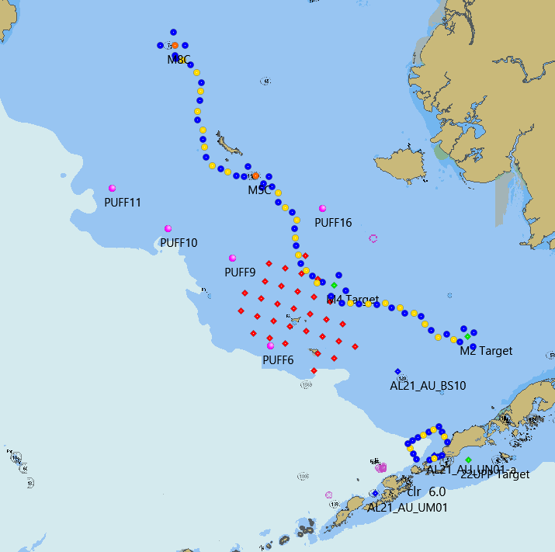

3. 72m Isobath CTD/Bongo Stations. CTD only stations are in yellow.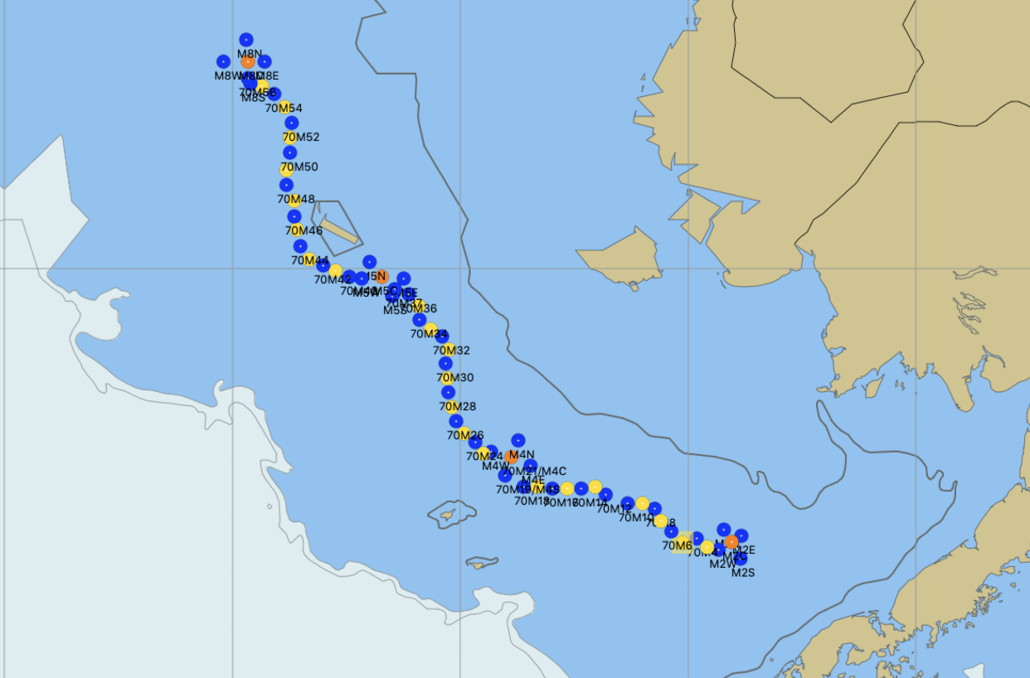

4. Unimak Box CTD/Bongo Stations. CTD only stations are in yellow. 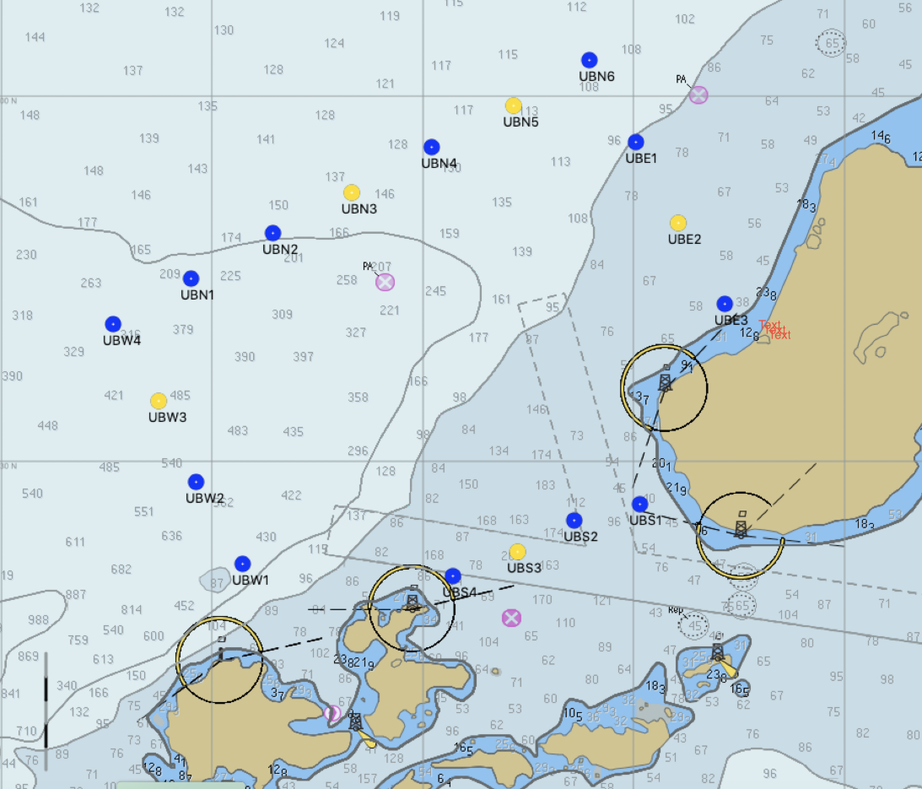

5. Pop Up Mooring deployment sites. A maximum of five sites will be occupied.

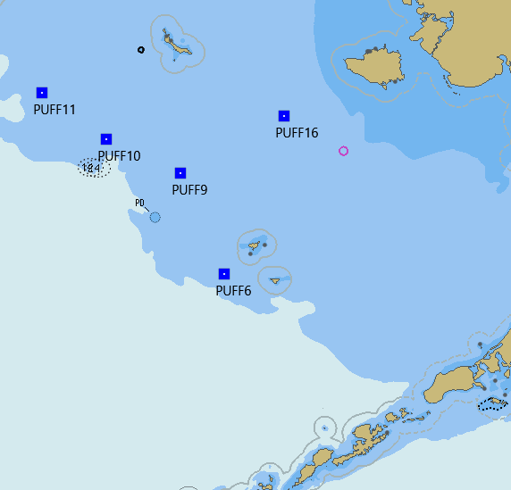

6. Mooring Locations. Green are FOCI moorings and blue are MML mooring.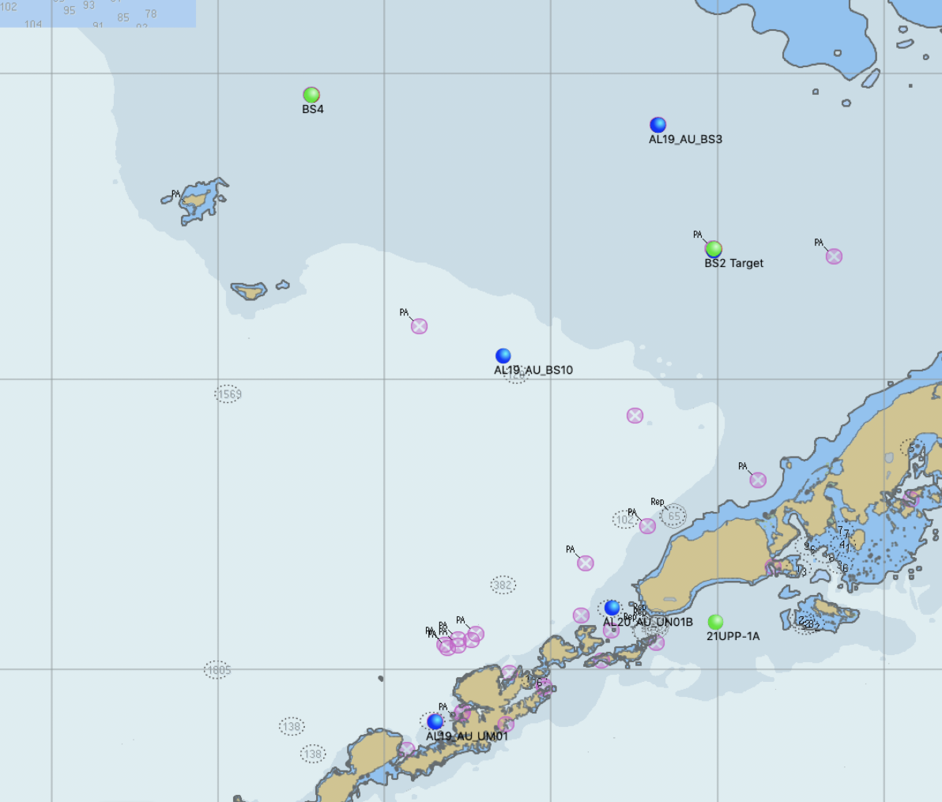

7. Bongo Survey Stations.

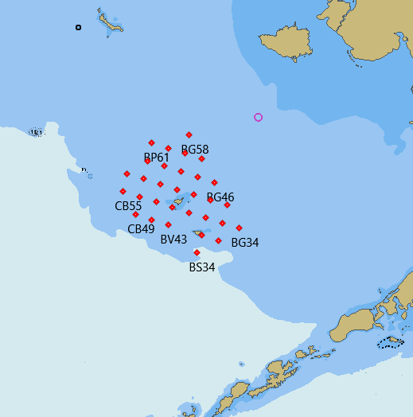

**Appendix II: Mooring Diagrams**

**22BSPR-2A**

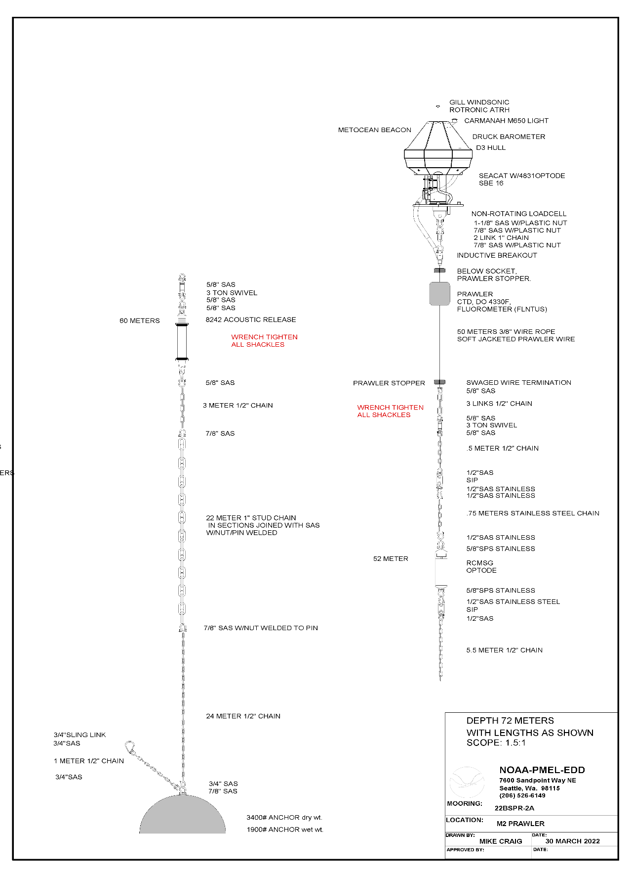

**22BSM-2A**

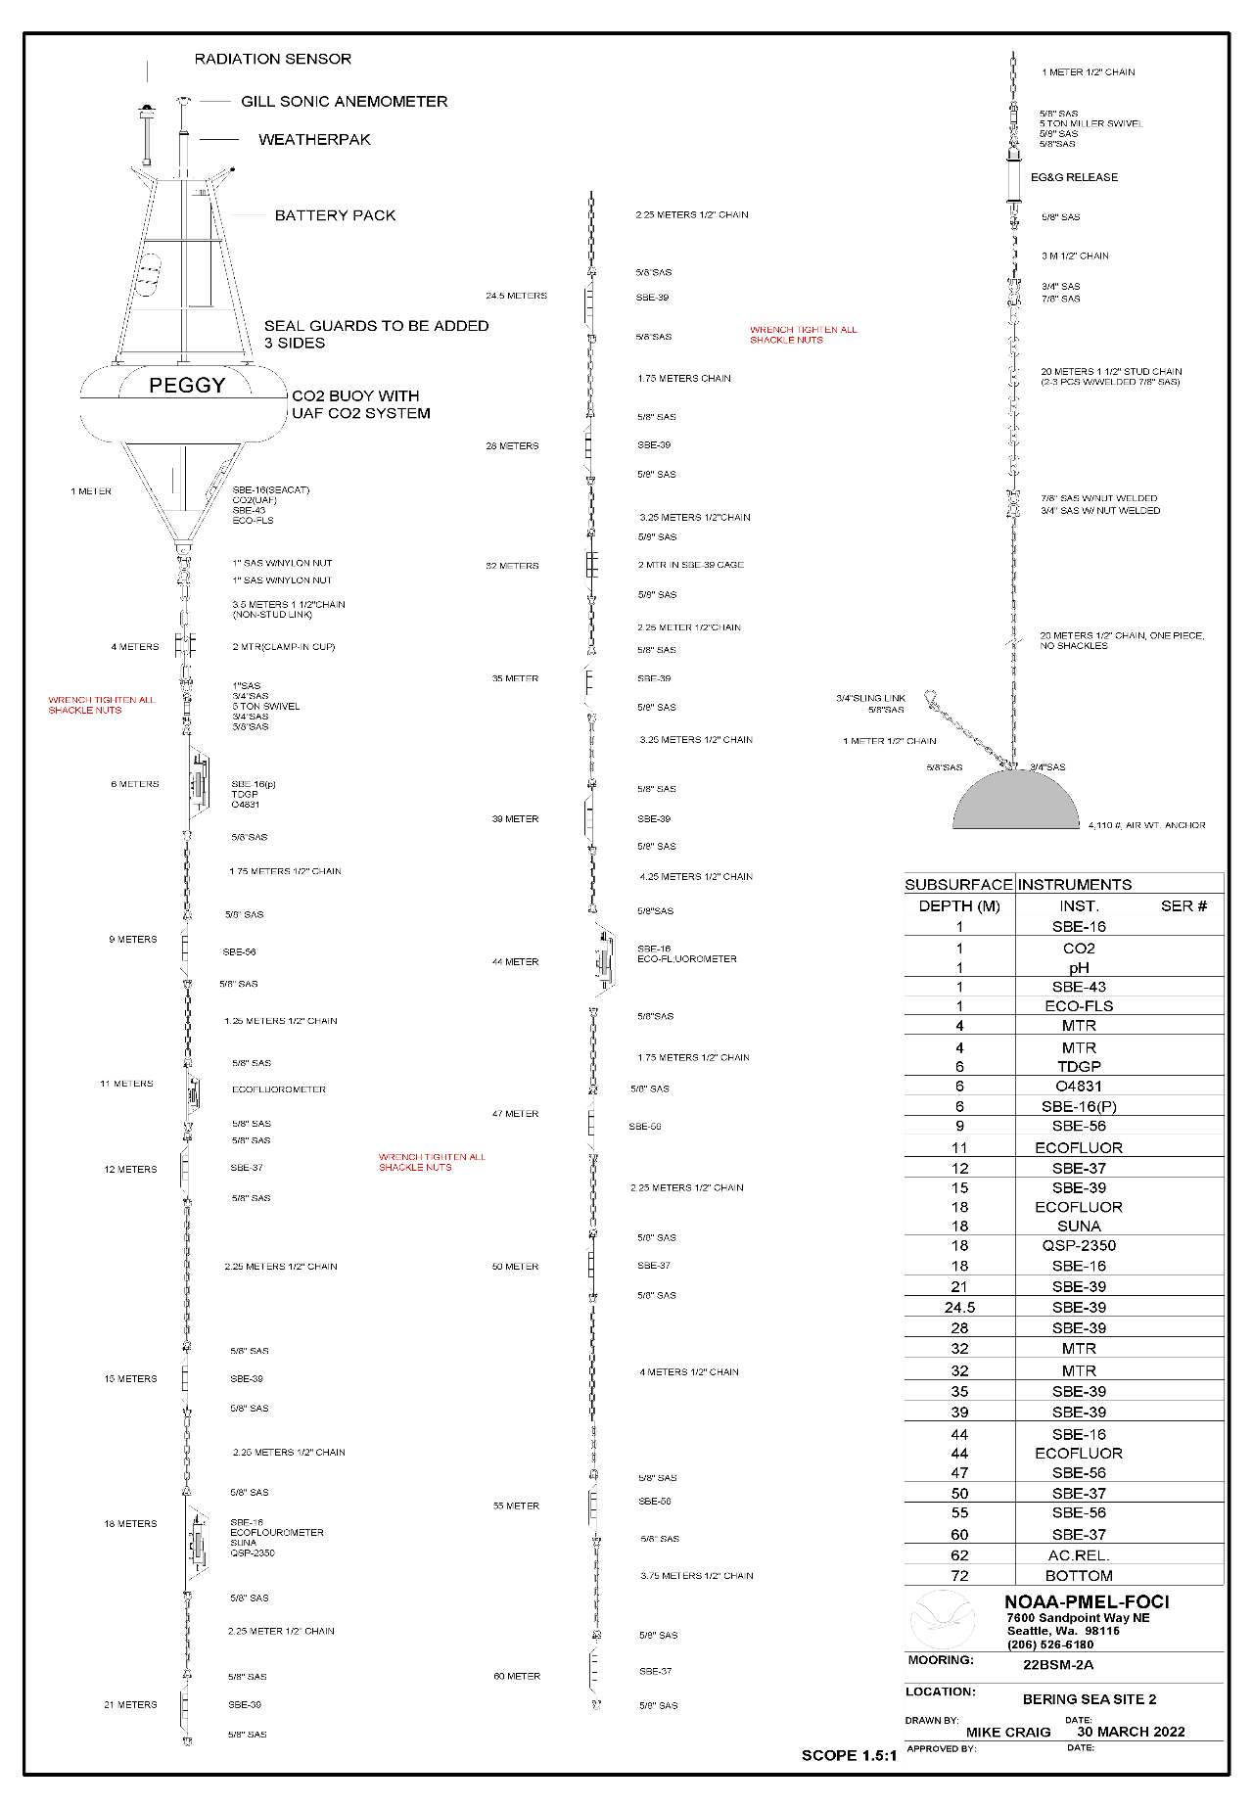

**22BSP-2A**

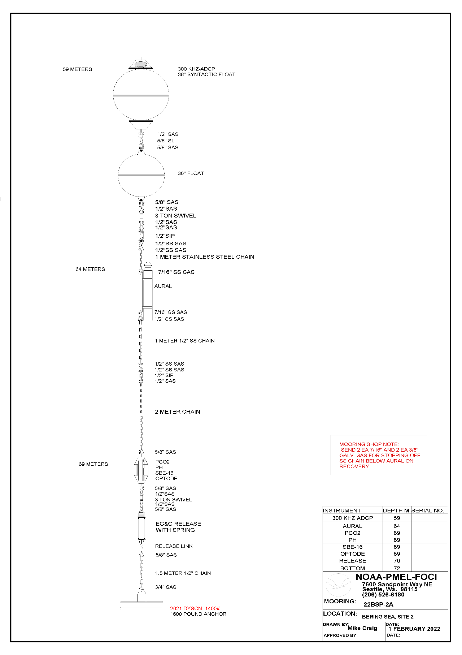

**22BS-4A**

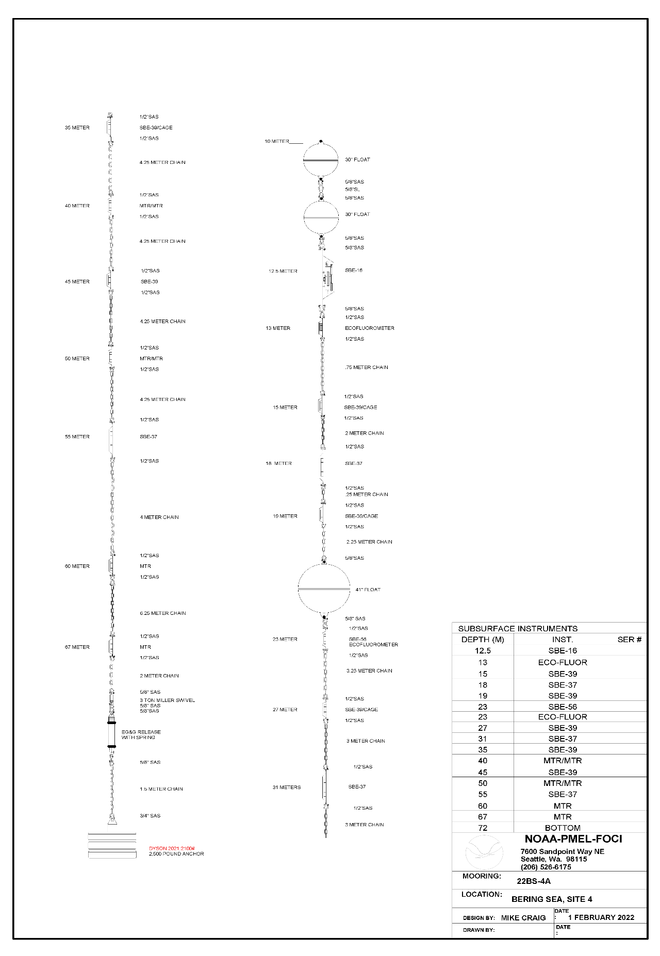

**22BSP-4A**

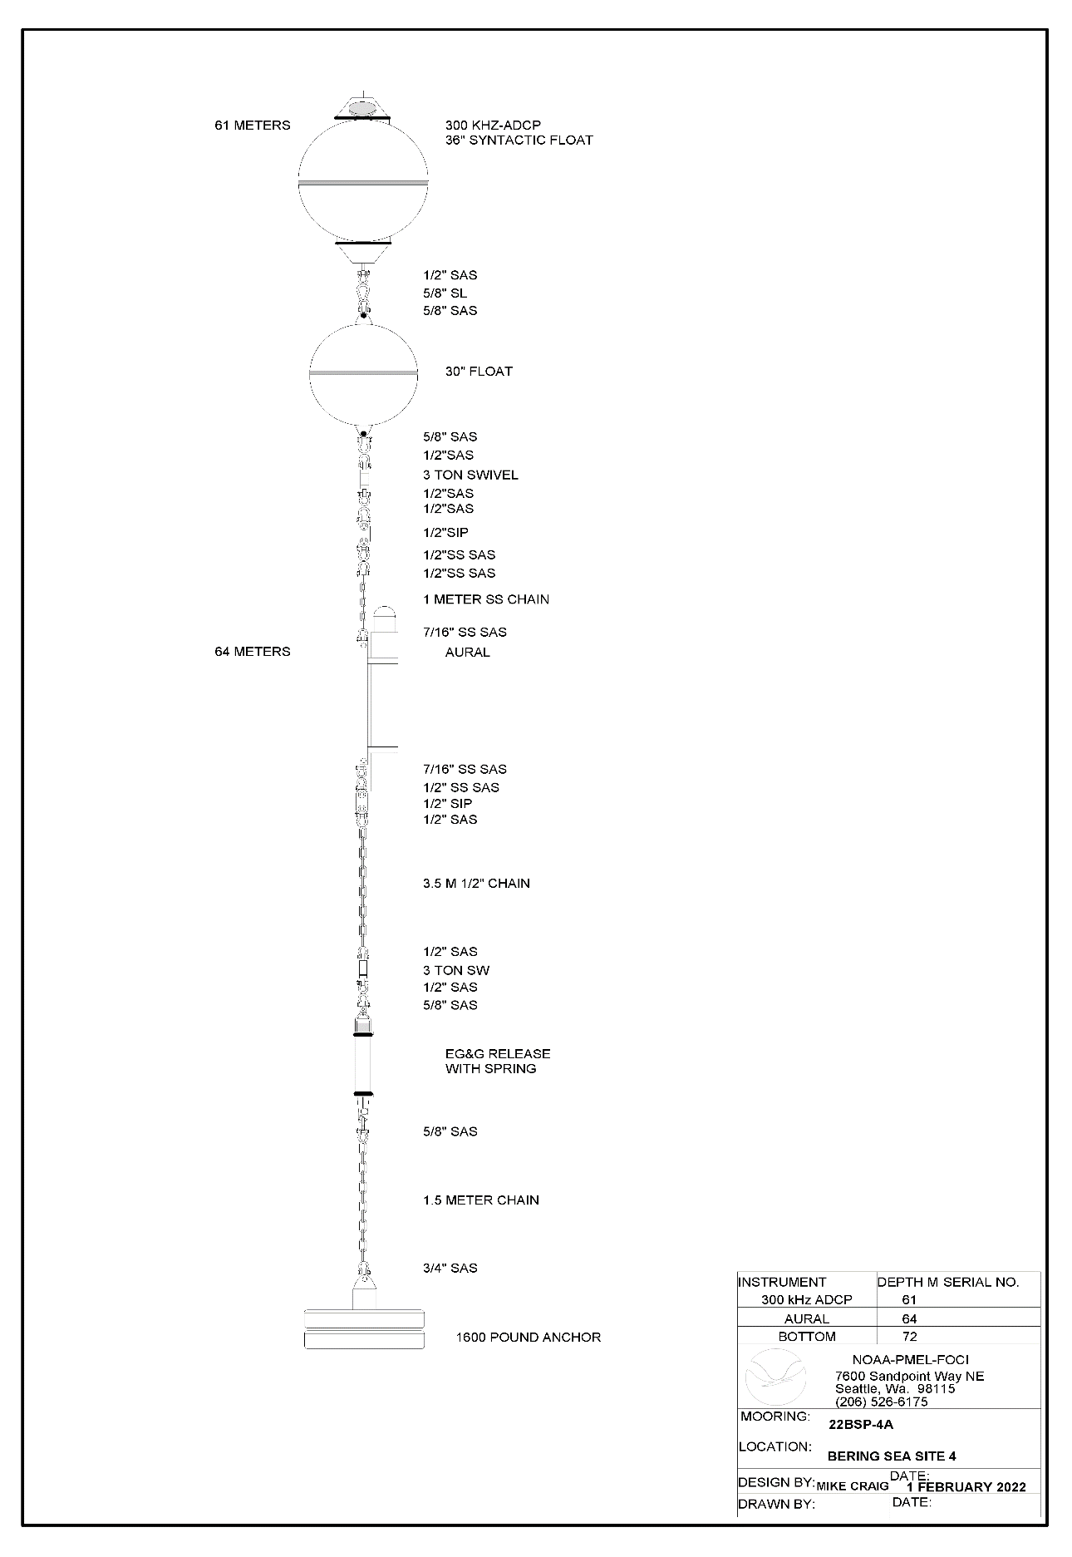

**22UPP-3**

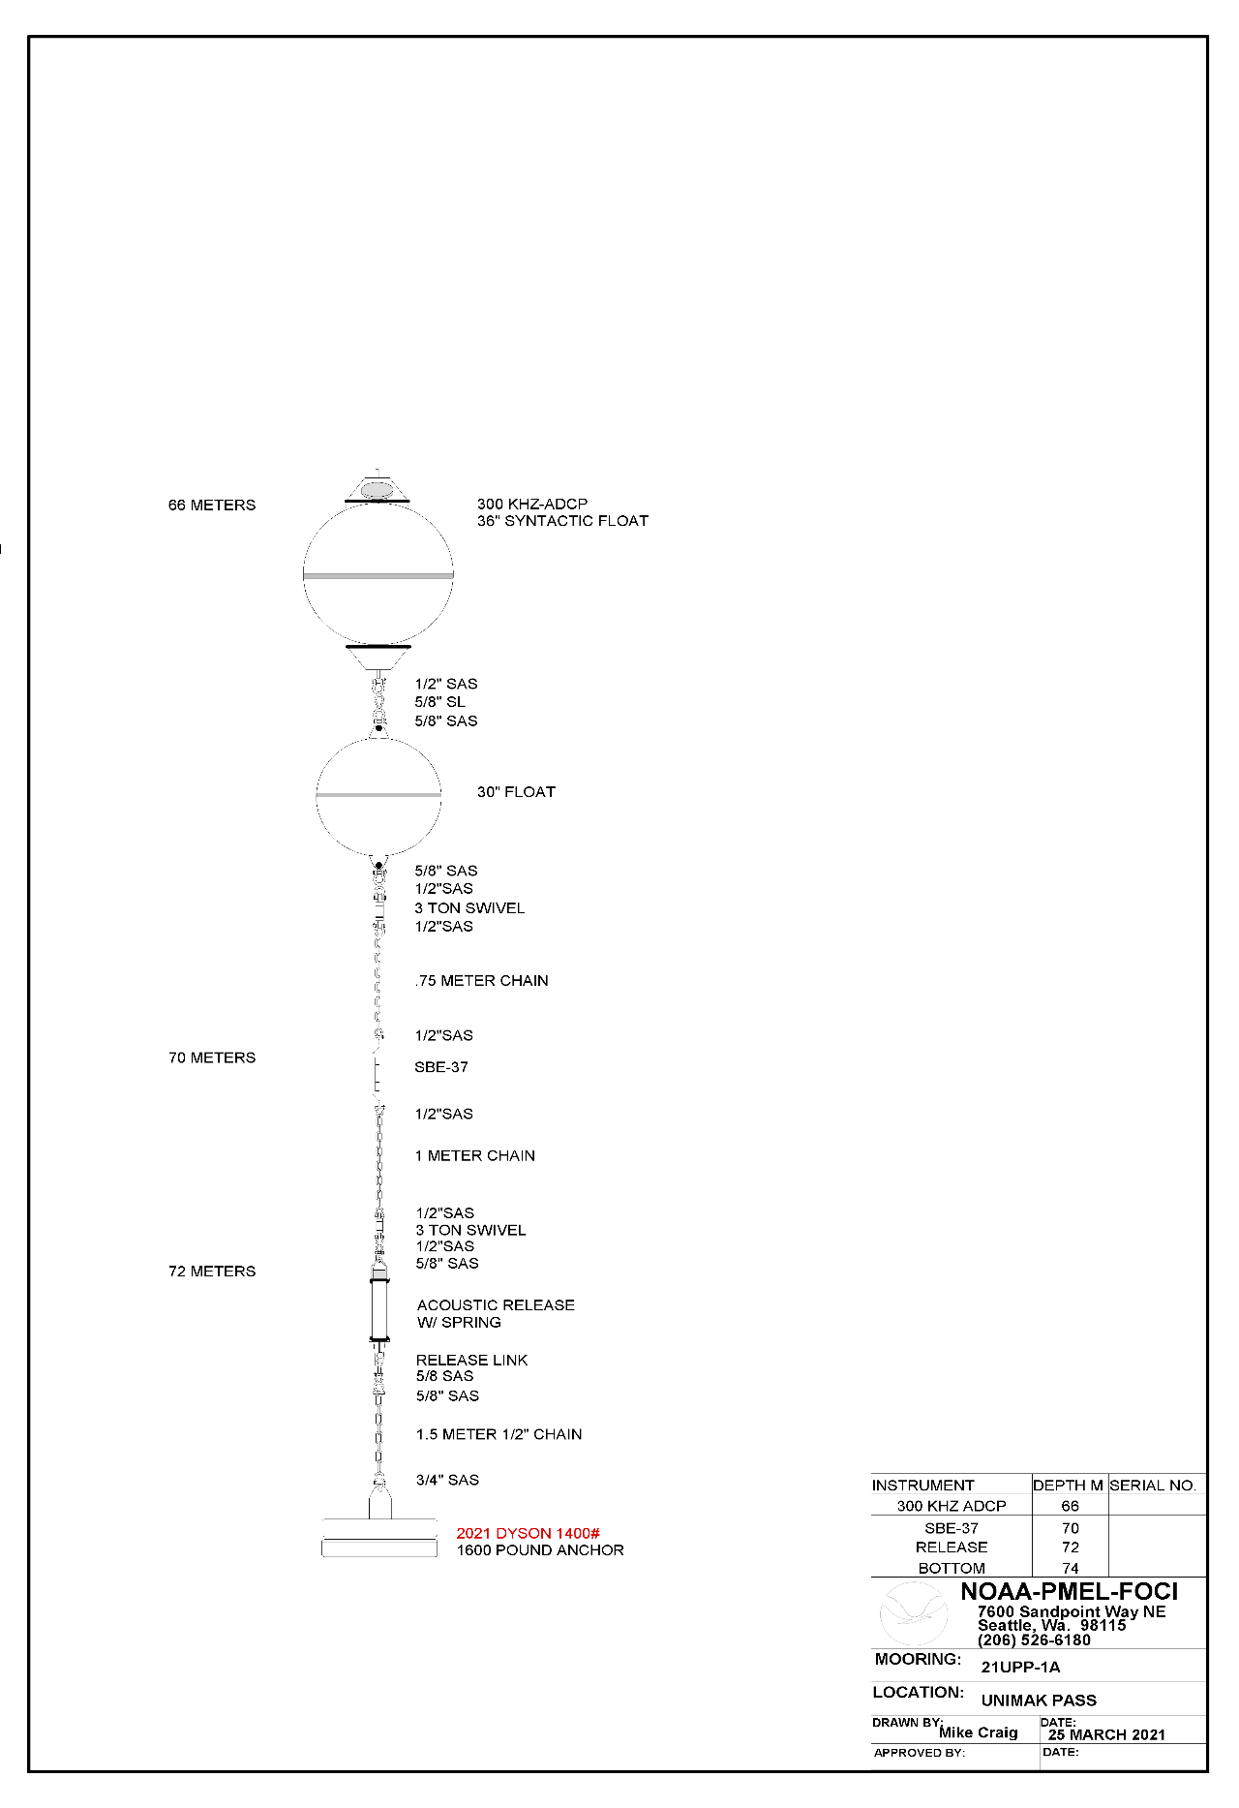

**Marine Mammal Mooring**

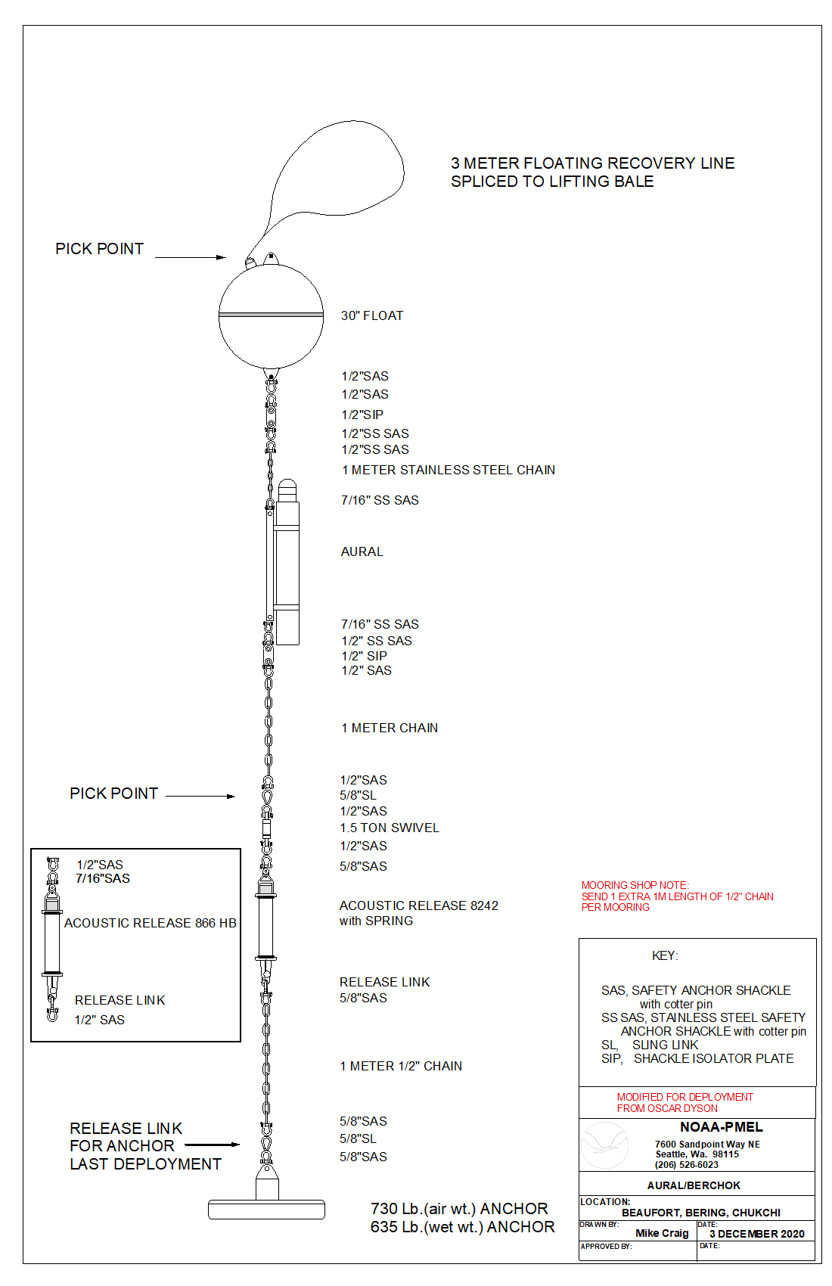

**Appendix III: Chemical Hygiene Plan**

Previous sections of the Project Instructions include a list of hazardous materials by name and anticipated quantity. Chemicals will be transported, stored and used in a manner that will avoid any spills and adequate containment, absorbents and cleanup materials will be available in the event of a chemical spill.

The scientific chemicals to be used for this project are: (1) ethyl alcohol (100%) and (2) formaldehyde (37%) and reagent chemicals for the preservation and analysis of oxygen samples. Other chemicals brought aboard are consumer products in consumer quantities. Dilutions of the scientific chemicals will be used to preserve *in faunal* organisms collected with towed zooplankton nets (bongos and CalVETs) as described in the Operations section of these Project Instructions and for the pickling and analysis of oxygen samples for calibration of the oxygen sensors on the CTD. Use of these chemicals and the specified dilutions will only occur in exterior locations on the ship away from air intakes. Scientific chemicals shall not be disposed over the side.

Standard Operating Procedures and Information Sheets are provided here for the scientific chemicals. Included are details concerning personal protective equipment, work area precautions, special handling and storage requirements, spill and accident procedures/first aid, waste disposal and other pertinent information. Both small and large spills are of particular concern; in both cases, the spill response is intended to first contain the spill and then neutralize it. This may be easily accomplished for small spills depending on the degree of vessel motion and the prevailing environmental conditions. In all cases, the first responder should quickly evaluate the risks of personal exposure versus the potential impacts of a delayed response to the spill and act accordingly. For example, if the spill is small and it is safe to do so, a neutralizing agent should be rapidly applied to encircle/contain the spill and then cover it. However, a large formaldehyde spill (> 1 L) is extremely hazardous and individuals at risk of exposure should immediately leave the area. The CO or OOD should be notified immediately so that a response team with self-contained breathing apparatus (SCBA) can be deployed to complete the cleanup operation or dispense the hazard with a fire hose directed overboard. The vessel’s course should be adjusted to minimize exposure of personnel to wind-driven vapors and to limit spread of the spill due to vessel motion.The reportable quantity (RQ) of formaldehyde is 1,000 pounds and the RQ for ethyl alcohol is 5,000 pounds which greatly exceed the quantities brought aboard for this project.

**Standard Operating Procedures – Formaldehyde At-Sea**

2 **3**

**20**

**32**

Chemical Name: 37% Formaldehyde

UN Number: 1198

Hazard Ratings: (on a scale of 0 to 4)

Health (blue): 3 Flammability (red): 2

Reactivity (yellow): 2 Special (white):

Personal Protection Gear Needed

*gloves

*goggles or face shield

Special Handling Instructions

* If a ventilation hood is not available, then pouring of chemical must be done outside. At least two people should be involved with large chemical transfers in case of an emergency.

* Chemical must be stored at temperatures above 15o c to prevent polymerization of paraformaldehyde.

First Aid

* If swallowed, give large amounts of drinking water and induce vomiting.

*If vapors inhaled, get out into fresh air immediately. Give oxygen if breathing is difficult.

* If spilled on skin or splashed in eyes, flush with water for at least 15 minutes.

Spill Cleanup Procedures

**For small spills** (500-1000 ml):

Cover spill quickly with a Fan Pad and spray on Formalex to deactivate and absorb chemical. Let material sit for 10 - 15 minutes. Dispose of materials in plastic bag.

**For large spills** (>1000 ml):

Use a combination of Fan Pads and Formalex as quickly as possible to contain spill and deactivate it. Vacate area and try to ventilate room, if possible. Call Bridge immediately (x101).

Deactivation/Disposal Procedures at Sea

*Formalex is a greenish liquid that is to be used to insure proper chemical deactivation. Formalex should also be used in conjunction with Fan Pads. Place used Fan Pad in plastic bag, seal, and put in bottom of Spill Kit.

*Fan Pads may be used to absorb small spills alone but these pads work best when used with Formalex to immediately control the vapor layer.

Shipping Procedures and Restrictions

37% formaldehyde cannot be ship by air due to its flammability rating.

All quantities should be over-packed with absorbency material in case the original container is damaged. When shipping by barge or land, labels are not required for quantities under 110 gallons by D.O.T. but the container should have MSDSs and the UN number readily available.

**Standard Operating Procedures – Ethanol At-Sea**

**3**

**0**

**2**

Chemical Name: 100% Alcohol

UN Number: 1170

Hazard Ratings: (on a scale of 0 to 4)

Health (blue): 2 Flammability (red): 3

Reactivity (yellow): 1 Special (white):

Personal Protection Gear Needed

*gloves

*goggles or face shield when pouring

Special Handling Instructions

* Keep away from heat, flame, and other potential ignition sources.

* Store in a well-ventilated area or in a flammable cabinet.

First Aid

* If swallowed, give large amounts of drinking water and induce vomiting.

* If vapors inhaled, get out into fresh air immediately. Give oxygen if breathing is difficult.

* If spilled on skin or splashed in eyes, flush with water for at least 15 minutes.

Spill Cleanup Procedures

Absorb ethanol with 3M Sorbent Pads and allow to dry in a well-ventilated area away from ignition source.

Deactivation/Disposal Procedures at Sea

Use 3M Sorbent Pads to absorb the ethanol. Put used pads outside to dry (secure from blowing overboard and exposure to flame). Once dry, the pads may be reused or burned.

Shipping Procedures and Restrictions

Due to the flammability rating of 95% ethanol, this chemical cannot be shipped by air. Transportation by barge or land vehicle will require the ethanol container to be over-packed with absorbent materials such as clumping kitty litter or shredded paper. Include MSDS and the UN number with the shipment for reference in the event of a spill.

**Appendix IV: Table with Estimated Weights.**

|  |  |  |  |  |  |  |
| --- | --- | --- | --- | --- | --- | --- |
| **Mooring Name** | **Anchor Wt.** | **Chain Wt.** | **Instrument Wt.** | **Releases** | **Floats** | **Total Wt.** |
| 21UPP | 1600 | 100 | 100 | 112 | 400 | 2312 |
| 21BSM2 | 4000 | 2295 | 600 | 112 | 2000 | 9007 |
| 21BSP2 | 1600 | 100 | 500 | 112 | 400 | 2712 |
| 21BSPR2 | 3500 | 1500 | 350 | 112 | 1015 | 6477 |
| 21BSP4 | 1600 | 100 | 260 | 112 | 400 | 2472 |
| 21BS4 | 2400 | 448 | 400 | 112 | 740 | 4100 |
| MML moorings | 2550 | 201 | 700 | 336 | 330 | 4117 |
| Other Equipment |  |  |  |  |  |  |
| dragging Hooks |  |  |  |  |  | 400 |
| CO2 Equip |  |  |  |  |  | 600 |
| Mooring gear |  |  |  |  |  | 500 |
| tires |  |  |  |  |  | 600 |
| Misc. Equip. |  |  |  |  |  | 640 |
| Lab Equip |  |  |  |  |  | 400 |
| sonobuoys |  |  |  |  |  | 1800 |
| Popups (4) |  |  |  |  |  | 360 |
| zoop |  |  |  |  |  | 1500 |
|  |  |  |  |  |  |  |
|  |  |  |  | Final Estimated Weight* |  | 37997 |
|  |  |  |  |  |  |  |

*Final weight to be provided to the Captain before loading, not to exceed 38,000 pounds.